**Logistic Regression - Cost Function**

The cost function measures the inaccuracy of a Logistic Regression model across all the sample data.

The function used to evaluate the performance of a machine learning model is called a loss function, or a cost function.

To evaluate how “good a fit” a model is, we calculate the loss or cost for each data sample (how wrong the model’s prediction was) and then average the loss across all samples.

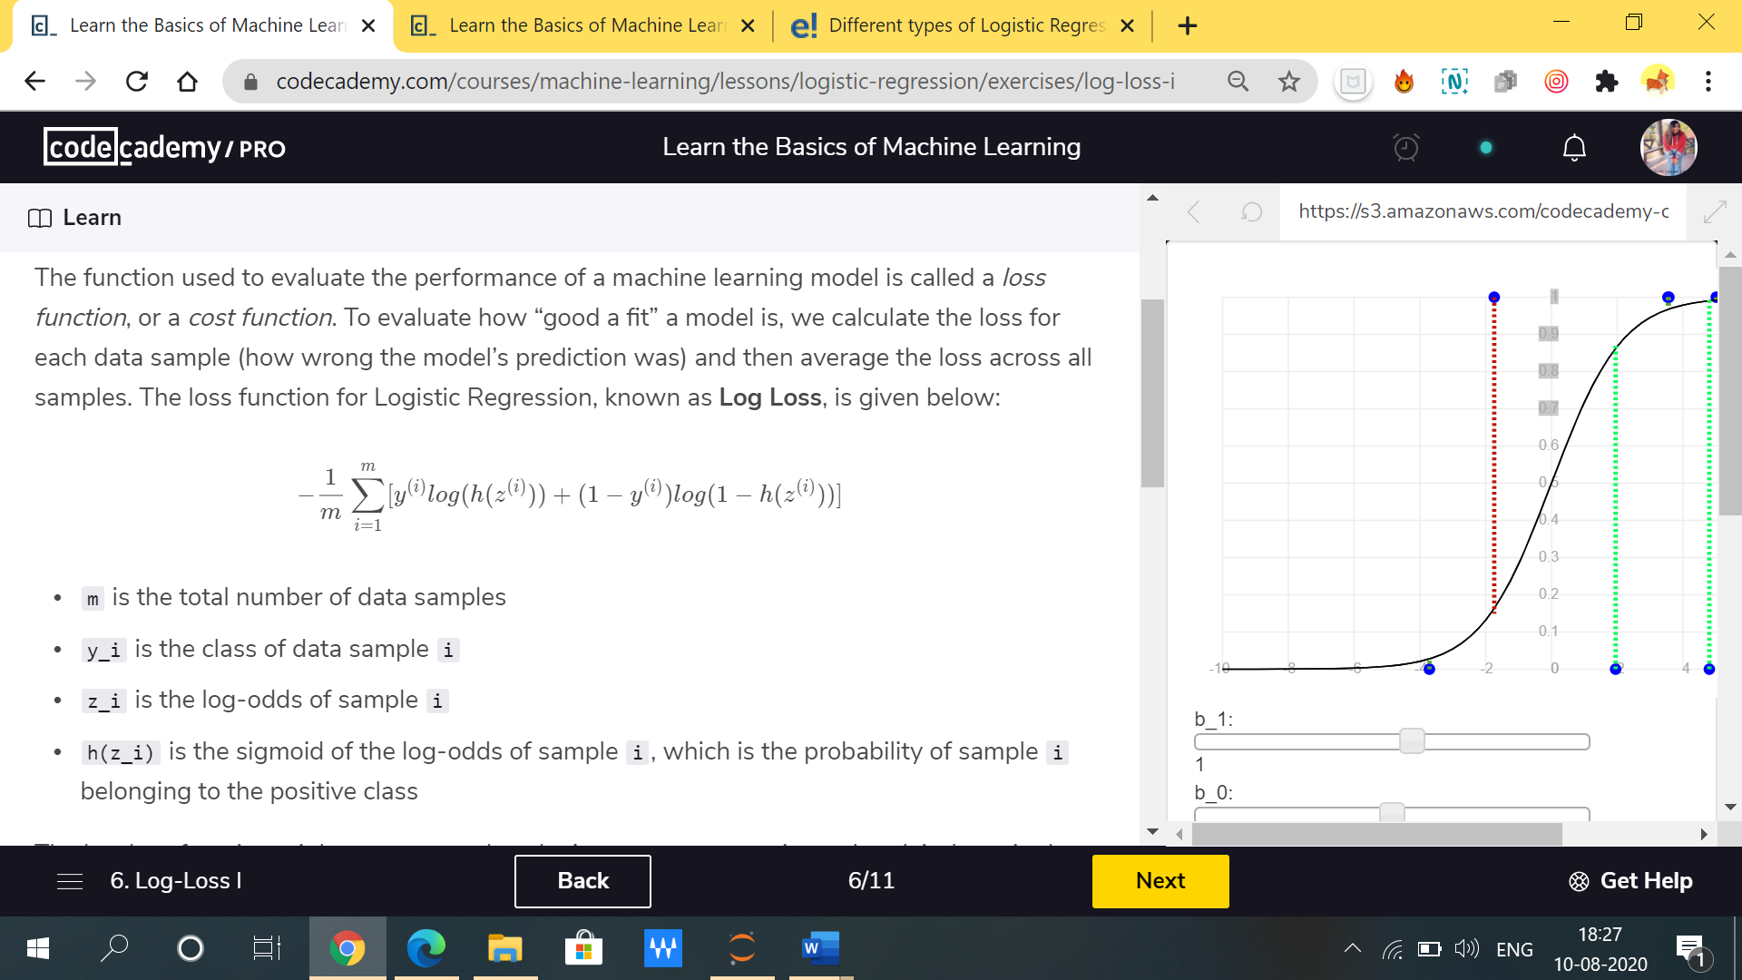The cost function for Logistic Regression, known as Log Loss, is given below:

Where,

m is the total number of data samples

y_i is the class of data sample i

z_i is the log-odds of sample i

h(z_i) is the sigmoid of the log-odds of sample I , which is the probability of sample i belonging to the positive class

**Problem- Prediction of passing the final exam of student**

Let’s go ahead and break down our log-loss function into two separate parts so it begins to make more sense.

Consider the case when a data sample has class y = 0, or for our data when a student failed the exam. The left-side of the equation drops out and the loss for that individual student becomes:

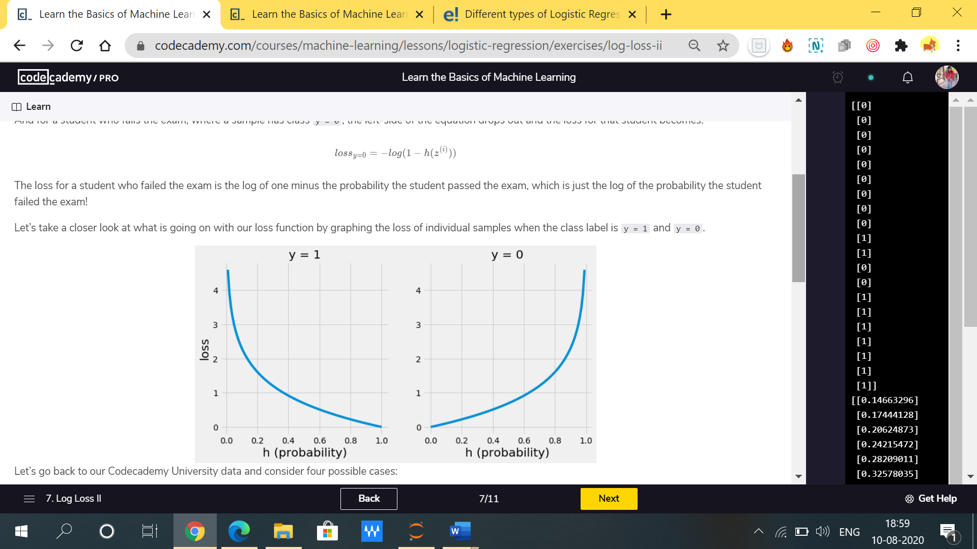

**Let’s understand with the graph**

Take a closer look at what is going on with our loss function by graphing the loss of individual samples when the class label is y = 1 and y = 0 i.e. (student pass exam or not).

Parameter of graphs-

1. Y-axis: It represents the cost or loss function.
2. X-axis: It represents the probability of a classified decision in the range [0 1]
3. Graph with y=1 or y=0 represents the label that classify the class i.e. student pass the exam or not respectively.

From the graph1 with y=1 where it considers the students who pass the exam, you can see that correct predictions result in small losses that means it will output with more precision and accuracy.

While in graph2 with y=0 where it considers the students who did not pass the exam, you can see that incorrect predictions result in large losses that approach infinity.